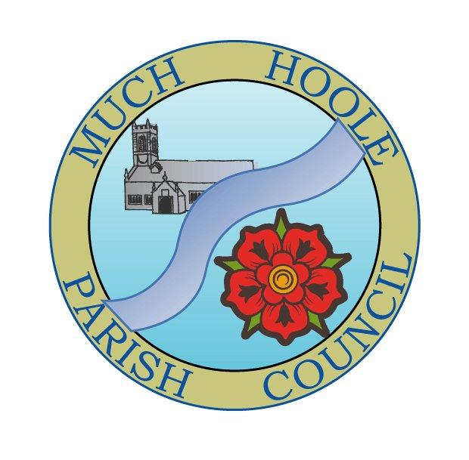 | MUCH HOOLE PARISH COUNCIL  NOTICE OF MEETING
You are hereby summoned to attend the Meeting of Much Hoole Parish Council to be held at 7.30pm on Monday 11th October 2021. The meeting will be held at the Venue (Hoole memorial village hall) Liverpool Road.
Russ Weaver, Clerk

AGENDA
1. | Apologies for Absence  To receive apologies for absence.
2. | Declaration of Interests and Dispensations  - To receive declarations of interest from Councillors on items on the agenda  - To receive written requests for dispensations for disclosable pecuniary interests (if any)  - To grant any requests for dispensation as appropriate
3. | Minutes of the Previous Meetings  To resolve to approve as a correct record the Minutes of the Council Meeting held on the 13th September 2021
4. | Public Time  To invite and listen to issues raised by members of the public.
5. | Off Road Cycle Track  To consider any updates on the Cycle track and resolve any actions required.
6. | Finance and Audit  To resolve to authorise payment of the following:  - To resolve to pay the clerk salary in the sum of £240 (net) for September  - To resolve to pay the Clerk expenses for mileage for September in sum of £10.80  - To resolve to pay HMRC in sum of £60 PAYE for September  - To resolve to pay invoices for PKF Littlejohn external auditors in sum of £960  - To pay invoices to Village Hall for use of meeting rooms (May to September inclusive) in sum of £40.00  - To resolve to approve £100 for funding as prizes for the forthcoming Halloween competition  - To NOTE the findings of the external audit.
7. | Community led projects  To discuss and update progress on the spending of community funding.
8. | Grant applications  To consider and resolve to approve two grant applications  - Request from Revd. Templeman for the sum of £5,500 as a contribution from the Parish Council towards the cost of building a community meeting lodge at the Parish Church  - Request from Much Hoole Scouts for £2,000 to provide lighting on the currently unlit path to and from the Scout Hut  Grant applications for both have been circulated.
9. | Planning  07/2021/00955/NMA 50 Barnfield, Much Hoole, PR4 4GE
  Non material amendment to planning application 07/2020/00036/HOH for reduction of two-storey side extension to single storey side extension to single-storey side extension with mono pitch roof
10. | Training  - To resolve to approve payment for training course (via LALC/PTT) for the Clerk on Finance at a members cost of £25  Course to be held via Zoom 7pm – 9pm 14th October 2021  - To consider whether any other Councillors wish to attend and if so, to resolve to pay £25 for additional attendees.
11. | Local Meetings (for information only)  To receive any reports from local meetings.
12. | Items for the Next Agenda (for information only)  To highlight issues for the next agenda
13. | Date of Next Meeting  The Parish Council to agree the date of the next meeting as 7.30pm Monday 8th November 2021, to be held at ‘The Venue’, Liverpool Road, Much Hoole.

